**Python Unit Testing**

<https://github.com/Deepanshu-TTN/bootcamp-git/tree/master/week-5/Unit%20Testing>

setUp function, always run first, setup attributes for testing

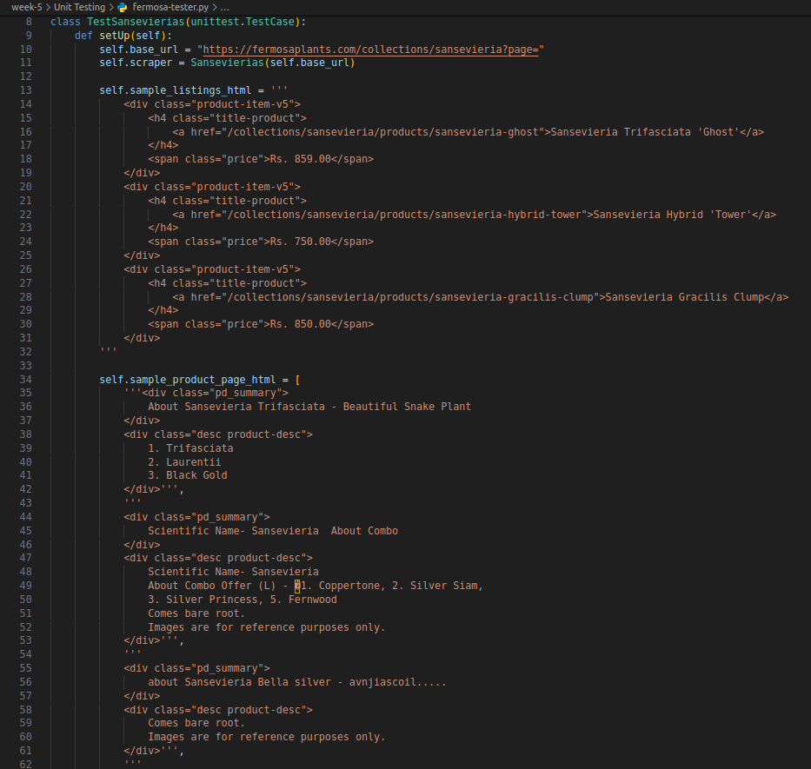

Get_soup test, patch requests.get for better simulation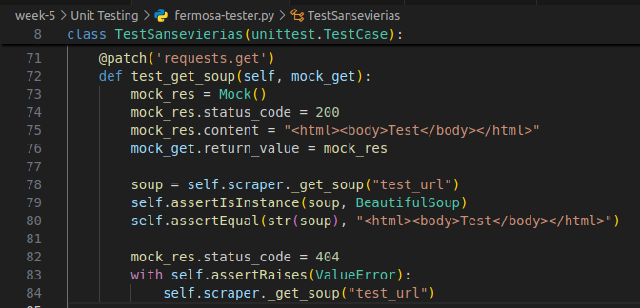

Scrape_page test, patch get_soup function to get mocked with dummy data provided above

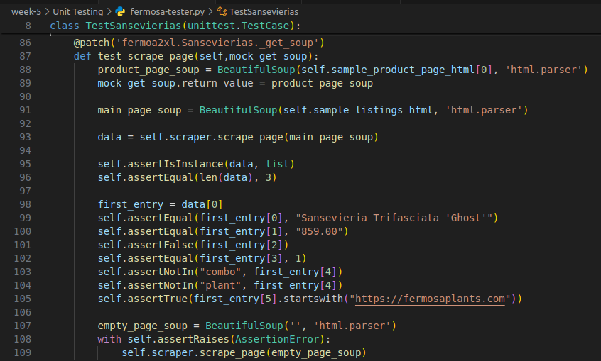

Extract_names test, test 4 different cases from setup function to ensure working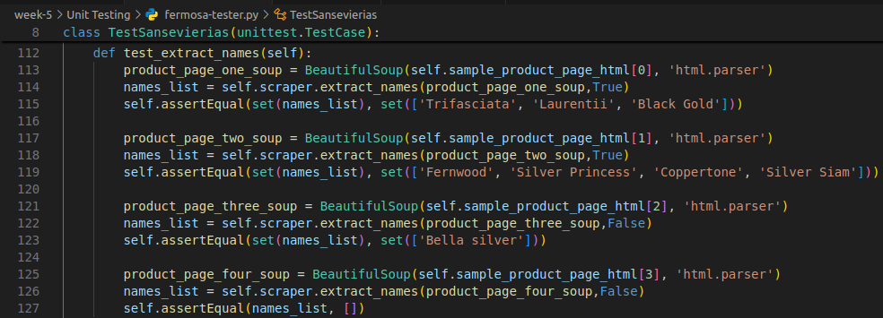

Scrape_from function test, patch 2 different dummy responses to cover all paths

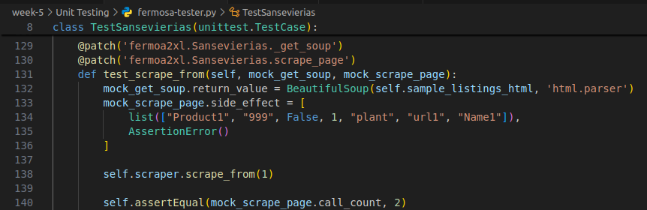

Test run:

